

TIB DIGITAL BANKING SOLUTION

Business and Technical proposal by Tech-board Company Limited

[Date]

[Company name]

[Company address]

Contents

INTRODUCTION 1

PROBLEM DEFINITION 2

Financial inclusion 2

Financial disciple 2

Convenience 2

Accessibility / Reach 3

Security 3

SOLUTION SOFTWARE MODEL 4

Introduction 4

SOFTWARE ARCHITECTURE – VIEW 5

Online banking 5

Mobile banking (Android and iOS) 6

Sim banking (USSD application) 7

Administration platform (Web Application) 8

Dashboard application for data presentation and analysis (Web application) 9

TIB payment API 9

Interface architecture and technology 10

SOFTWARE ARCHITECTURE – MODEL 16

SYSTEM ARCHITECTRUE - Controller 17

Solution design plan and methodology 20

Mile stones and Deliverables 21

IVR/SELF SERVICE 22

SOLUTION EXTRAS 22

Social platform 22

Digital marketing assistant 22

User credit and investment index 22

Light weight mobile option 22

24/7 customer support 22

Multi-language support 22

Solving financial inclusion 22

Solving Convenience, Access and Security 23

SEVPESA PLATFORM 24

How it works 24

SEVPESA Projections and business model 26

SEVPESA CUSTOMER PROBLEMS (we are trying to address/solve) 27

SEVPESA SALES/MARKETING STRATEGY 27

SEVPESA COMPETITORS 28

SEVPESA SOCIAL IMPACT 28

CONCLUSION 29

# INTRODUCTION

Tech-board company limited, as within this document referred as Tech-board, is a research, design and innovation company registered under the Tanzanian companies act of 2002. The company’s scope of works ranges from designing FIN-TECH solutions for banks and microfinance industries to interactive case management and reporting solutions to both public and private agencies. We are also involved in the design, development and maintenance of Intelligent transportation systems (ITS). Our focus is leveraging technology for the betterment of the local community.

As is our name, pronounced “Tech Dash Board”, Tech-board is defined by its attention to writing software platforms that are centralized, user friendly, secure and most importantly, custom made for our clients and partners. In laymen terms, all our platforms are tailored to serve specific needs and solve specific problems. We employ the latest technology in software design, deployment and operations to ensure that our platforms are safe and secure. Tech-board is also an official technical partner with the Tanzanian National Internet Data Center, a government agency committed to software innovation, internet safety and security. This proposal is focused on presenting the new TIB completely mobile, digital banking solution that includes an online, mobile and SIM banking platform. The solution also consists of a payment API for e-commerce and the fully automated saving platform code named SEVPESA.

The proposed solution is built to increase financial inclusion in the country by extending banking service to people outside the scope of banking areas. Most of these users are those that either physically reside in areas where TIB banking services have not yet reached or those that, due to time constraints, need banking on the go. Our solution is 95 percent mobile meaning that, apart from physically walking to the ATM or bank branch to get hard cash, our users will be able to utilize 95 percent of the banking services online or through their mobile devices. This does include account opening services.

# PROBLEM DEFINITION

### Financial inclusion

The percentage of people with access to bank accounts has steadied at 8 percent in Tanzania.[1] The number is even lower if you factor in gender, poverty status and urbanicity. While just about 50 percent of Tanzanians are financially included through mobile money accounts, those connected through formal banking institutions stand at the bottom of the list. This shows that more than 90 percent of the population has no access to the broad spectrum of services that formal banking institutions can offer as opposed to the mobile money accounts which are almost, only focused on transferring funds and digital payments.

### Financial disciple

The need for saving, investment and other forms of long term goal oriented saving accounts all surround one major concept which is financial discipline. Tech-board R&D team conducted a research and on the sample size of 50 participants, over half admitted to cashing out their savings account to cover short term emergencies. The lack of financial discipline has resulted into many losing sight of the long-term goals hence stunting their economical welfare.

### Convenience

A simple checking account opening process in Tanzania involves filling out an average of a 2-page form and a trip to the local government office for an introductory letter. It also involves taking a passport size photo to attach with the application and a signature and thumb print to certify[2]. Most checking accounts have conditional maintenance fees and minimum balance requirements to keep the account open and active. Access to one’s money is limited to in-bank teller services, ATM usage or in rare cases, sim banking services. I will leave out the part which involves queuing for customer services and limited banking hours during the weekends and public holidays.

### Accessibility / Reach

About 74 percent of the Tanzanian population lives in rural areas hence remaining outside the formal financial systems which mostly exist of branches placed in urban locations. [3] These are those people who mostly perform transactions in cash or via mobile money transfers and are physically out of a banks reach.

### Security

There is no doubt that being in possession of paper money makes one a target of robbery and attack. The trip to and from a physical banking location has made many business personnel and accountants victims to robberies. This has led to most people deterring away from accessing banks simply because of physical security. The alternate which has been mobile money and traditional group savings has rendered some relief to those seeking personal security with their finances even though this has alienated individual from profiting from the services banks can offer.

# SOLUTION SOFTWARE MODEL

### Introduction

The proposed software shall be a SIM (MOBILE) and Online banking platform custom written as a solution for the TIBCBL users and administrators. This solution, designed from scratch, will include and integrate:

* All present features offered by the current TIB banking software solution
* The fully automated account opening and saving platform (SEVPESA)
* A mobile banking module comprising of android and iOS platform applications
* A highly amped USSD code application for automated SIM banking with increased KYC architecture
* A mobile and online payment API for e-commerce services

This banking system shall focus on three major themes which would be to **centralize**, **modernize** and **secure** the TIB banking software platform for the purposes of providing better customer banking experience, generating quality data for enhanced banking administrative needs (investing, marketing, sales) and to enhance the overall quality of the user banking experience and banking management of user accounts.

The solution shall be written using the latest coding standards. It shall be designed according to the MVC architectural pattern using Angular on the client side and PHP and MYSQL on the server and database respectively. These specific languages were selected due to their immense performance and stability in the current market but also because of the ease they shall create in the operations and maintenance of the platform. The solution shall rest on a farm of Centos 6.9 servers which will utilize a load balancer for maximum uptime and efficiency. The platform shall also utilize minimal dependencies on the client side to perfectly accommodate the network capacity challenges faced in the clear majority parts of our country. This simply means that the system shall be built to be secure yet light weight on the client for maximum operability even in low bandwidth areas.

The proposed work methodology shall comprise of solution deliverables divided into five parts. These are as outlined below:

1. Delivering the online banking module
2. Delivering the USSD coded application coupled with the SEVPESA platform
3. Delivering the Administrator and Dashboard panel
4. Delivering the SIM banking platform comprising of Android and iOS applications
5. Delivering the TIB payment API

This proposal shall present the Model View Controller architecture and other solution components as outlined next.

### SOFTWARE ARCHITECTURE – VIEW

### Online banking

TIB online banking will be designed to enable TIB customers to access their bank accounts and services through a secure online platform. This will be available online through any browser on devices such as the desktop, laptop, tablets and mobile phones. The banking features for this online platform shall include

1. Automated enrollment
2. Secure authentication
3. Banking and account information
4. Account balance check
5. Paperless statements
6. Account alerts
7. Access to loan applications, document uploading and decision notice
8. Secure messages
9. Customized account offers
10. Pay and money transfers
11. Profile and settings
12. ATM and branch information
13. Feedback
14. Investments options
15. Help and support
16. Access to SEVPESA account

### Mobile banking (Android and iOS)

The TIB mobile banking platform shall be designed to enable TIB customers to access their TIB bank accounts and other connected TIB services through a mobile app written for both the Android and the iOS platforms. These apps shall be rendered through the play store for android and the apple store for iOS. The banking features for this mobile platform shall include

1. Automated enrollment
2. Secure authentication
3. Banking and account information
4. Account balance check
5. Mobile check deposits
6. Paperless statements
7. Account alerts
8. Access to loan applications, document uploading and decision notice
9. Secure messages
10. Customized account offers
11. Pay and money transfers
12. Profile and settings
13. ATM and branch information
14. Feedback
15. Investments options
16. Help and support
17. Access to SEVPESA account

### Sim banking (USSD application)

The TIB SIM banking running on a USSD code platform shall be built to enable banking access to the customer who does not have access to both online and mobile app. Though the services will be limited, the user will be able to access basic banking features from any registered mobile phone with USSD code capability. The features included in this application will include:

1. Automated enrollment and automated account opening
2. Secure authentication
3. Banking and account information
4. Limited text statements
5. Account alerts
6. Text banking
7. Limited loan applications
8. Customized account offers
9. Pay and money transfers
10. Feedback
11. Investments options
12. Help and support
13. Access to SEVPESA account
14. Enhanced KYC backed by NIDA and TCRA integration

### Administration platform (Web Application)

The TIB admin platform shall be designed to allow a control GUI for the TIB admin to seamlessly monitor and control the TIB banking mainframe. This platform shall consist of admin features that will allow admin to fully control and automated the mainframe with a custom-made GUI hence reduce the technical requirements needed for system management. It shall be built to make sure that anyone with the correct clearance will be able to administer the mainframe. The features included in this platform will include

1. Automated enrollment with approval required
2. Secure authentication
3. Admin privilege cluster views
4. User account management
5. Report generation and automation
6. System feature overrides and suspension
7. Mass messaging and push features
8. Chat
9. Profile and settings
10. System back up scheduler
11. Help and support

### Dashboard application for data presentation and analysis (Web application)

TIB Dashboard application will be an internal dashboard design to solely present and show case system data for marketing and performance evaluation purposes. The data will include comparisons between set milestones and what has been achieved and consumer data that can be applied for management purposes. The dashboard shall consist of the following features.

1. Automated enrollment
2. Secure authentication
3. Chart and graph analytic tools
4. System statistics
5. Data query
6. Reports

### TIB payment API

The proposed TIB payment API shall be a payment API mechanism that will be designed as a payment endpoint for ecommerce merchants whose accounts are hosted at TIB. This API shall be custom made with documentation to enable e-commerce and online customers receive payments directly into their TIB account from the web and/or mobile applications. The features of this API shall include:

1. Automated enrollment
2. Secure authentication
3. Automated sales/money reports
4. Simple plug and play type of implementation
5. Secured by client ID and client secret authorizations provided by TIB
6. Payment mechanism available 24/7 anywhere around the world
7. Quick funds availability for merchants
8. Tax support features available on option
9. Priority customer support

### Interface architecture and technology

#### Interface security

The user interface of the proposed solution is designed with system safety and security starting at the view level which is the outward appearance of the solution. Clear-cut measures shall been taken to ensure safety of the system beginning at the authentication level to the interaction that the multiple tier users shall have with the system. All administrator level users will require a two-step authentication module that will involve their password and a onetime code offered by google authenticator password algorithm. Users will also be provided with the option of using the two-step authentication if they choose. This is one of the many interface security features as outlined below.

##### Authentication

1. Automated account opening

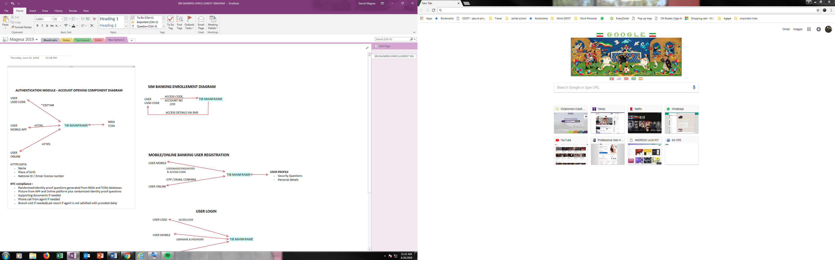

1. User registration

All users shall be required to register with the system before access. The users shall request and be provided with a onetime authentication code during account opening that shall be required when enrolling for online, mobile or Sim banking. Users will also have to provide answers for security questions which will be stored and used in the password recovery process as explained later. Users shall also be required to confirm their email address and enter a onetime code either provided through their registered email or phone number before gaining access to the system. Furthermore, all administrator level users shall require system approval by an approved supervisor before being able to access the system. The diagrams below step out the user registration process for different platform components.

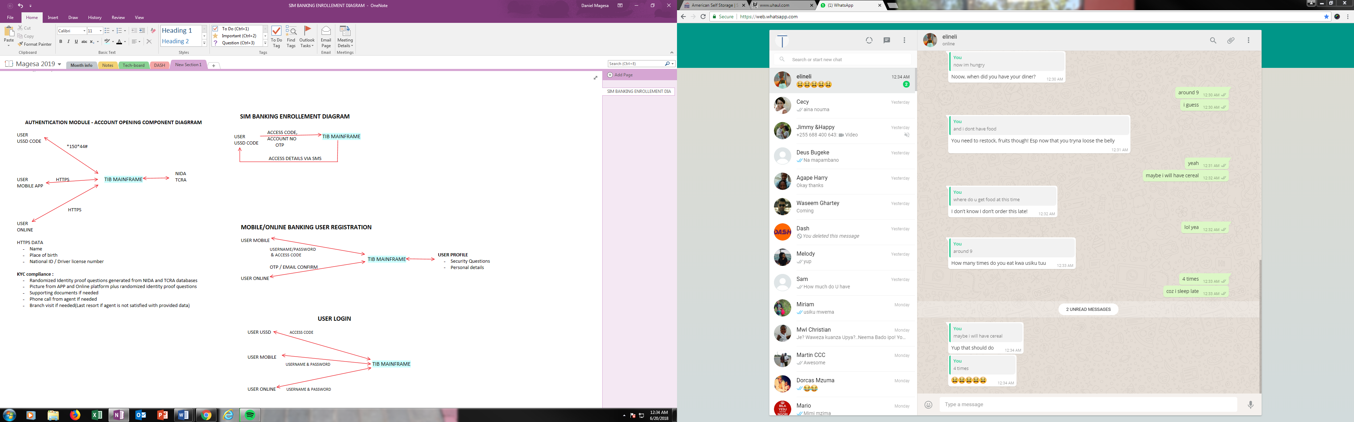



1. Login

Once a user/administrator has completed the registration process, he/she will need to login the system every time they require access. Logins will be done securely with a username and password for the normal banking users and username, password + onetime code for the administrators. SIM banking users will use an access code to authenticate their transactions. All login sessions will be logged for a period of one month and all login activity, login location and devices shall be monitored. This means, a user shall be asked to reconfirm their login if they attempt to use a device that they have never used before. Administrators shall not be able to login their accounts from remote devices unless using a secure VPN. The login mechanism for different system components is as diagramed below.



1. Password recovery

All users and administrators shall have access to the password recovery component in case one forgets their password of feels like their password has been compromised. Password recovery for users is done by identify confirmation that can be performed through security questions and sending a OTP to the users registered email or phone number. Administrators will have performed the same steps but they will require a supervisor to complete their password recovery process. The mechanism through which all this is done is as diagramed below.

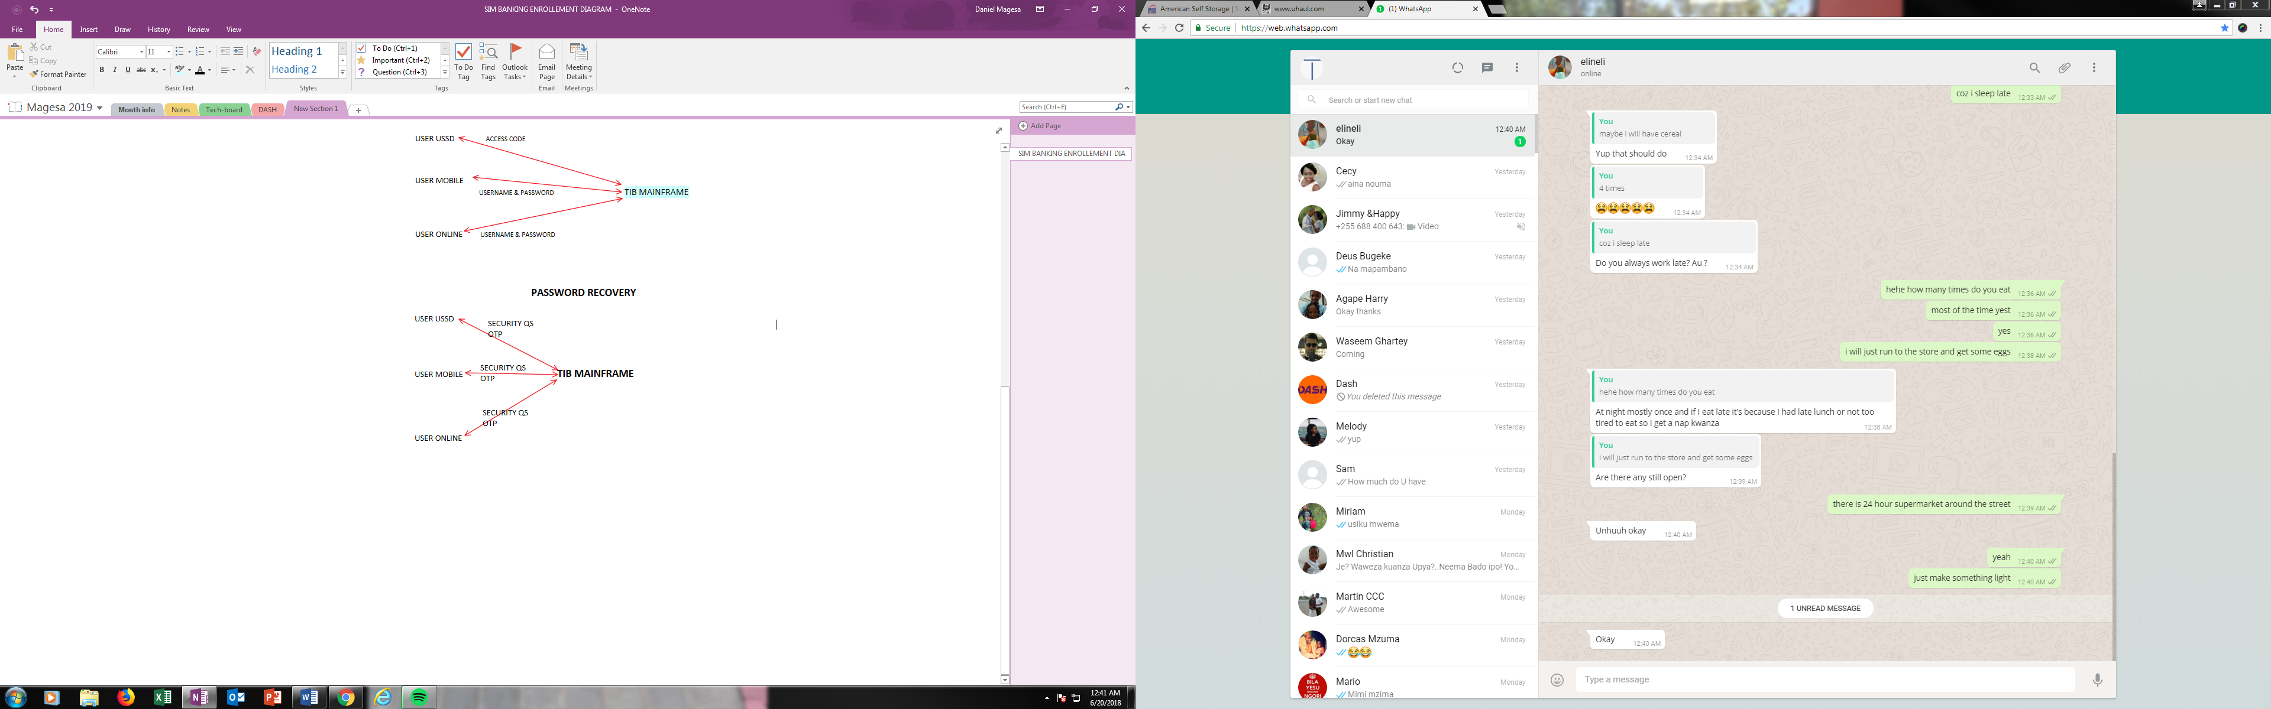

1. One Time Passcode

As outlined above, Onetime codes and passwords shall be utilized to proof identity of both users and the devices used. This shall be an added security later to ensure that the person who is accessing the system is in-fact who is identified by the system.

##### Device and location tracking and recognition

In enhancing system security and KYC, the system shall track user’s devices and locations to add another security later to authentications. This mechanism shall ensure that accounts are secure in case of any password compromising or theft. A user shall be required to confirm their devices with a onetime code to their registered email and/or phone number on file. The user shall also be asked for the same if they happen to access the system from a location that is not usually their own. The system shall also restrict transactions that will seem to origination from a foreign location other than the user’s norms. This shall be in place to secure user account safety. Users shall be notified when their account has been accessed on a new device.

##### Data encryption

All data transfers and exchanges shall be encrypted using the blowfish algorithm with salt. The system shall also implement and end-to-end encryption method on the internal secure messaging and customer support components. This shall ensure complete privacy in communications when users interact with customer care representatives and vice versa.

##### Automated logout

The solution is built with a no activity timer where a user gets automatically logged out after a certain period of inactivity. This will be to ensure that systems and user accounts do not get compromised in situations where someone forgets to logout of their account. This mechanism shall be implemented in all the components of this solution including the online, the mobile and the administrator component of the solution. The SIM banking commands shall also be set on a timer meaning that users who leave halfway will be automatically ‘logout’ out due to inactivity.

##### Password expiration

All users shall be required to reconfirm or change their passwords after a period of six months. This will reduce the risk of passwords being compromised through browser hacks for people who like to use the same password for everything. Users will also be required to change their password if there are any reports of theft or identity fraud in the user account.

##### Password strength

The solution authentication module shall require users to set their passwords such that they comply with the banks passwords rules. These will include things like a minimum number of characters, not having usernames or first or last names as part of the password. These checks shall be implemented for safety of the user account.

##### BOT restrains

The solution shall also implement a captcha system to prevent BOTS from automating activities of any kind.

##### Authentication logs

All system access logs shall be archived and stored for evaluation and security purposes.

##### Screen shot restrictions

Mobile uses will not be permitted to take screen shots of any view from the TIB mobile banking application.

### SOFTWARE ARCHITECTURE – MODEL

#### Database architecture

The database design shall be a 3-tier architecture which shall adopt the relational model. User data stored shall be compartmentalized to function and not components. Furthermore, users shall be assigned a unique identifier to associate with their personal data rather than their actual identity. This shall serve as a precaution in case of breach. There shall also be a division between the authentication module and the transactional module where one would be independent of the other but only relatable through the unique identifier.

The database design will comprise of the following databases

1. Users
2. Transactional
3. Operations
4. Administration
5. Archives

All database credentials shall be stored in an encrypted file only accessible to the system during runtime. Database activity shall be secured and monitored to prevent any injections or false dumps. Furthermore, all data and queries shall go through a validation barrier before being executed against any of the databases. These validation barriers include the user or prepared statements and data sanitization among the few.

#### Database features

The proposed solution database shall adopt all the security features offered by the mainframe. These include a firewall layer to mitigate network traffic, a mod security browser firewall to prevent any attempted SQL injections and attacks of the like and a design system that shall ensure minimal data leaks in case of attack. The database will also be configured to work with the load balancer to allow operability during a minimal RTO. Furthermore, this design shall enable database scalability when the need arises without shutting down or compromising system performance.

#### Database Hardware

The platform will run an Apache/2.4.33 server (server-side) and a 5.6.39 MySQL Community server (GPL) on the database. These are proven system guaranteed to deliver quality server-side processing. Our back-end will be written and run on PHP 5.6 language while the front-end client-side web will be written in Angular 5 following the MVC framework.

#### Database redundancy and management strategy

The system shall be managed through the administrator UI that shall be created to provide some database hard wire functionality through a GUI. A hard wire direct command line to the DB shall also be available. Database shall be configured with the load balancer to ensure redundancy during hot and cold backup times. Database shall be back-up daily hence providing a setback point in case of system compromise.

### SYSTEM ARCHITECTRUE - Controller

System controller shall be the center component of the solution where all data processing logic shall be performed. The controller shall be written in PHP following the Object-Oriented Programming (OOP) code architecture. System shall be divided into routers, classes and methods that shall create a smooth interaction between the view and model to provide for a better digital banking platform. The controller design shall also follow common coding and commenting standards hence making it easy for maintenance and upgrade.

#### Controller Hardware

The system shall be built on a Linux server running Centos 6.9 64Bit. There will be several static and dedicated IP’s configured as access points to the machine with a guaranteed uptime of 99.9%. We shall achieve this by utilizing our partnership with the National Internet Data Center where the system will be hosted. We will work closely with our partners to ensure system upkeep and uptime is maintained. The servers will be configured to a farm with a load balancer for maximum request handling efficiency. A few server features shall include

* 4 cores, 8 threads Intel Xeon Processor
* 8 MB Cache
* 1000 GB (RAID 1)
* 15 TB/Month
* Initially configured with 5 dedicated static IP’s

The system server is local hence runs on all local location settings including time and date. System shall also be configured to fit the business calendar as instructed by the bank. This will be an admin feature installed with the design.

#### Controller Network hardware

Alongside great quality programming would be a network infrastructure that shall consist of a Cisco RV220W firewall with following standards for added internet security

* IEEE 802.11n, 802.11g, 802.11b,
* 802.3, 802.3u
* 802.1X (security authentication)
* 802.1Q (VLAN)
* 802.11i (Wi-Fi Protected Access [WPA2] security)
* 802.11e (wireless quality of service [QoS])
* IPv4 (RFC 791), IPv6 (RFC 2460)
* Routing Information Protocol (RIP) v1 (RFC 1058), RIP v2 (RFC 1723)

The controller shall also include an automated reporting module that will run a reporting script over on crontab as shall be requirement by system administrator. The system shall consist of GUI that will be used for easy report configuration and can produce both CSV and pdf reports on request and automatically. These reports shall consist of everything to anything from system stats to routine performance measures. Include with the controller design for logic and data processing shall be the following modules as outlined below

#### Error capturing and handling

This module shall be a center router for all system and programmatic errors. The errors shall be achieved and reported through an automated ticket issuing system for quick resolutions. Appropriate user-friendly error messages shall be displayed accordingly.

#### View-Controller communication protocols

All communication protocols shall be over https on a secure socket layer (SSL). These shall involve communications from the mobile and sim banking components as well as the online and administrator banking solutions. Communications shall also encrypt and compress all transfer data for data protection and transfer efficiency respectively.

#### System deployment, upgrading and updating

System deployment shall be conducted in five phases as stated earlier in the introduction to this model. The first deployment phase shall include the administrator control component which shall include all system controls and back end GUI support. The second phase shall include the online banking module and all its components. The third and fourth phase shall include the deployment of the SIM and Mobile banking platforms including the SEVPESA platform while the fifth and the last shall consist of the TIB payment API. Periodic system maintenance, feature addition and development shall continue as per TIB requests to Tech-board.

#### Controller user support

All deployments shall be accompanied by the following support components

1. Online support – Chat and FAQ blog
2. Customer support from Tech-board customer support staff
3. Documentation for system support and training
4. Training facilitation for staff and admin
5. Landing pages for marketing and advertising

### Solution design plan and methodology

This proposal covers a broad scope of works that shall range over a predicted time of 15 months. During this time our team shall work closely with the TIB team to ensure that all designs and specs are followed according to specifications and all requirements are met as shall be discussed. The proposal suggests bi-weekly design meetings where milestones, performance and strategy shall be evaluated. The development team at Tech-board shall encompass nine (9) fulltime software engineers and one system administrator. These people shall fully commit a total of 2400 hours each towards the completion of this platform.

Since the bank has already a system in place and there are plenty of variables to consider before an agreement to proceed with design, all costs estimates shall be arranged after the submission and acceptance of this design proposal or upon request from TIB. The project details and milestone dates are as shown overleaf.

### Mile stones and Deliverables

|  |  |
| --- | --- |
| PROJECT MILETSTONE AND DELIVERABLES | |
| **DATE** | **ITEM** |
| 25-Jul 17 | Project Start |
| 22-Aug 17 | Database design |
| 19-Sep 17 | GUI - Online & Mobile |
| 17-Oct 17 | Authentication and security |
| 14-Nov 17 | Admin dashboard |
| 12-Dec 17 | Online banking |
| 9-Jan 18 | Mobile banking (android) |
| 6-Feb 18 | Mobile banking (iOS) |
| 6-Mar 18 | Mobile banking (SEVPESA) |
| 3-Apr 18 | Automated account opening |
| 1-May 18 | Public dashboard |
| 29-May 18 | Landing pages |
| 26-Jun 18 | User credit and investment index |
| 24-Jul 18 | Digital marketing assistant |
| 21-Aug 18 | Social Platform |
| 18-Sep 18 | Setting up 24/7 customer service |
| 16-Oct 18 | Project completion |

### IVR/SELF SERVICE

The solution shall be configured with endpoints that shall allow integration of IVR customer service and self-service ATM systems. Tech-board company limited shall work with approved vendors to achieve this service.

# SOLUTION EXTRAS

### Social platform

The solution deployment phase shall include a social media, customer service platform where users will be able to reach out to the bank directly from their social media accounts. These shall include Facebook, twitter, Instagram and WhatsApp.

### Digital marketing assistant

TIB marketing assistant shall comprise of a set number of digital marketing tools to enhance the digital presence of the TIB banking solution. These involve SEO integrated web pages and the user of google analytics and ad-words for advertising and data collection respectively.

### User credit and investment index

The system shall, under the SEVPESA module, run an algorithm to create the customer credit and investment indexes for each TIB customer. These indexes shall be based on user banking behavior in various aspects. The indexes shall be used alongside other tools that help the bankers decide on lending and providing other banking services to the customer.

### Light weight mobile option

The mobile banking solution shall consist of a light weight web option that can perform light weight functions without having the user to install the app from the stores. This shall be a mobile version of the online banking solution that can be set on the phone home page as a light weight application.

### 24/7 customer support

Tech-board shall employ a fulltime, 24/7 customer support service specifically tailored for system maintenance and support.

### Multi-language support

Platform shall be offered in a front-end GUI that supports both the Swahili and the English Languages. Both user and admin will be able to set their language preference.

### Solving financial inclusion

It is a known fact that banks want to get closer to the customer. However, based on the research, establishing a physical branch is rather costly. Considering the costs of infrastructure, the real estate and the manpower required to establish and run a physical banking location, the costs add up quickly. This leads to banks only focusing their branches and services to areas where they can justify making the investment. Mobile branches and automated ATMS have come close to solving this issue but even those attempts have not created much relief. This has been one of the reasons why a very small percentage of people in Tanzania have access to a bank. The new TIB digital banking solution was designed to increase financial inclusion by providing most of its banking services remotely via online or mobile interfaces.

### Solving Convenience, Access and Security

The TIB digital banking solution is designed to provide convenience, access and security to its user. The system being over 95 percent mobile would mean 24/7 banking for customers. The platform will also reduce the risk associated with carrying cash or having cash payments for merchants. This will increase customer security.

# SEVPESA PLATFORM

SEVPESA is fin-tech solution custom made for the Tanzanian banking institution. The service shall be offered as part of the new TIB digital banking platform. The focus of the SEVPESA service is to encourage and enable a saving and investment culture in the local community through mobile forms of banking. As the new TIB digital banking platform is already a fully mobile platform with automated remote account opening features, customers will be able to save and invest seemly from any place around the country. The diagram below states the few perks that will come with the SEVPESA service.

SEVPESA

* Financial discipline
* Financial inclusion
* Convenience
* Accessibility
* Security

CUSTOMER

BANKS

Figure 1 Image to show SevPesa methodology

The service shall be available through all the interfaces that will come with the TIB digital banking platform. These include, the online, the mobile and the SIM banking interface. The access to a savings and investment account without ever having to set foot in a physical banking location is anticipated in our country and shall greatly boost financial inclusion among many other things.

### How it works

The SEVPESA service will provide a user with a fixed deposit savings account that he/she can contribute money without the access to withdraw for a specific amount of time. The time could range from 1 week to 1 year. The user will be able to contribute into their savings via cash, mobile money account, TIB bank account or any other bank account. The user shall receive interest on their savings and be able to retrieve their money after that maturity period is complete. The short USSD menu seen on the diagram overleaf provides a glimpse of what the service will offer.

As said above, the aim of the SEVPESA service is promote financial discipline and inclusion. It is also set to provide banking convenience and accessibility by removing everything that people do not like about the traditional banking services. Users will be able to join SEVPESA remotely from any network if they have a registered phone number (even if they do not own a TIB bank account).

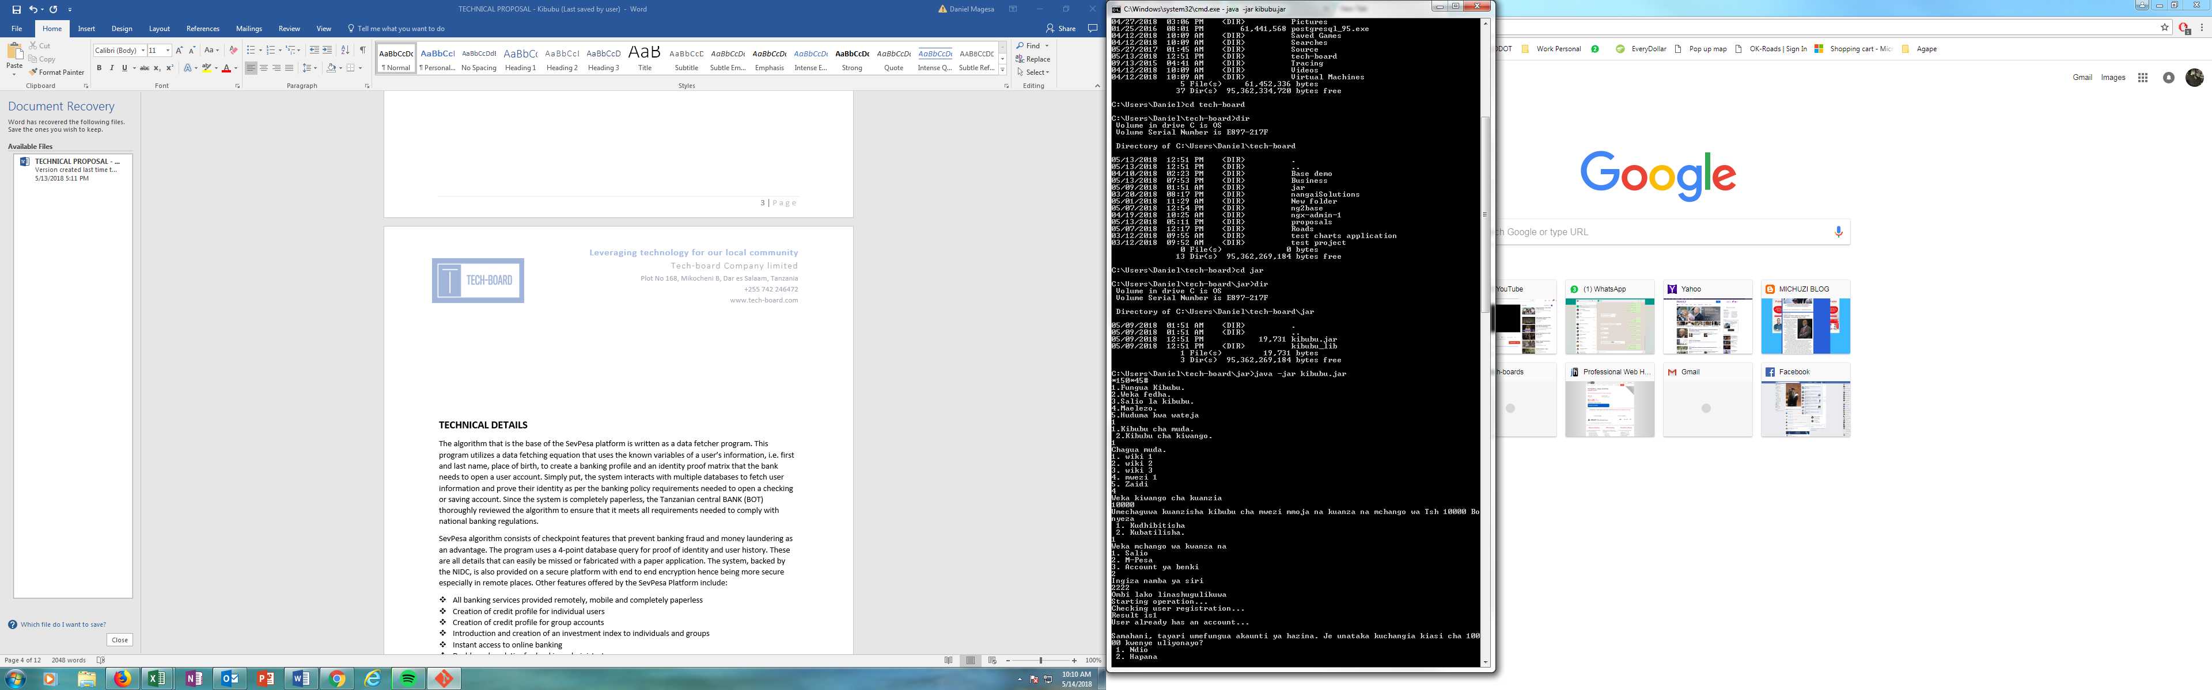

Figure 2 To show USSD code program for the SevPesa platform

As seen in figure 2.0 above, the user will first be connected to SevPesa Menu via a specified ussd code through the TIB banking platform. This will provide access to a menu that will lead them to creating an account. The menu also consists of options to deposit money into the account, check the account balance, information and an automated customer service request. All of this is built to increase safety, convenience and efficiency of the platform. The platform can also be accessed via a mobile application interface as shown is figure 3 below. The mobile application, just like the USSD enables the user to remotely open and manage a savings account from one’s finger tips in 4 easy steps. No paper work shall be required!

Figure 3 To show the mobile application demo for the SevPesa Project

# SEVPESA Projections and business model

SEVPESA has a projected project value of 192 Billion TSH. This value is based on the expected number of users which is based on the market share research conducted. The findings and estimations can be found in Appendix B with cost estimates and timeline. Tech-board shall implement a combination of several business models for the SEVPESA project. These include the Low-cost business model where revenue will be earned primarily through charging fees for our services and the Advertising model where target advertising will be implemented in our web mobile application interfaces.

For the Low-cost model, revenues are expected to be generated from: -

* Account maintenance and operations charge (charge per user per month)
* Charges for crowd sourcing platform services
* Charges for stock market tools and analysis usage
* Charges for health insurance connectivity and enablement
* Charges for bonds and securities services
* Charges for sports services.
* Charges for the SEVPESA payment system

For the Advertising model, revenues are expected to be generated from selling target advertisement which shall be a bi-product of our customer profile initiative. In this system, customers will be able to send target advertisement based on specific user needs.

For further information on the business model, please see the attached proposed business plan.

# 

# SEVPESA CUSTOMER PROBLEMS (we are trying to address/solve)

The first need we are trying to address is that of financial SAFE KEEPING with unprecedented convenience through a mobile phone without losing value by also incorporating a bank into the idea as a more qualified entity, a haven that people can trust with more legal monetary freedom than Mobile Network Operators hence more monetary value proposition.

Secondly, unlike the formal banking system, our service embarks on AFFORDABILITY meaning saving without losing or incurring any costs but rather gaining in due time through interest rates, loans, health insurance and other schemes of which all together serve the true purpose of saving.

Thirdly, strengthening FINANCIAL DISCIPLINE by removing unnecessary access to a well-planned vital part of an individual's funds which reduces the risk of unplanned expenditures hence reaching the planned goals as many times as possible.

Lastly, EMPOWERING individuals and groups of people with self-ability to raise their own CAPITAL by providing them a saving platform that financially disciplines them to eventually see their savings reach amounts that can act as capital or loan security so as to carry on their private or business endeavors.

# SEVPESA SALES/MARKETING STRATEGY

Our marketing strategy embarks on the customer journey loop as elaborated with the following formula;

AWARENESS = UNDERSTANDING = REGISTRATION = TRIAL = REGULAR USE

In each of the five stages there will be immense advertising through the MEDIA that is strategic radio and television ads through usage of famous local actors who'll be the face of the idea/service from the beginning creating ads of different customer scenarios depending on the situation of the targeted customer i.e. as a fisherman , driver or a farmer - who on the ad will constantly be encouraging fellow fishermen or farmers to use the service, but also through SOCIAL MEDIA (Facebook and Instagram) where reach is guaranteed due to the high use of mobile phones and the internet by advertising and promoting our services and website.

Also, through WORD OF MOUTH by strategically using friends, family, colleagues, influential people like former or active political leaders, sportsmen/women, businessmen/women and other field agents who can reach more people strategically.

PROMOTIONAL CAMPAIGNS through targeted groups of customers organized through their leaders like the leader of the farmers union who'll give us access to the farmers but also promotional campaigns through events whether in sports, music or cultural campaigns that can pull people together.

Lastly, ads on outdoor BURNERS and LIGHTBOXES.

# SEVPESA COMPETITORS

Main competitors are Mobile Network Operators offering mobile money services specifically 3 successful companies namely Vodacom(M-pesa), Tigo(Tigo pesa) and Airtel(Airtel Money) whom according to TCRA as of June 2017 have a market share of 31%, 28% and 26% respectively to an estimated 20 million subscribers. Their mobile money platforms are mainly designed for remittances proven by usage of more than 68% of the adult population and only 22% use the platform for savings while 7% of the adult population save their money in the bank. This proves that there is room for innovation in the savings arena

On the other hand, the competition is an advantage since their mobile money platforms can be used to incorporate our services just as MNO’s have used the BANK’s platforms in the past which gives us direct access to their customers.

# SEVPESA SOCIAL IMPACT

On REGULAR USE of our platform, individual FINANCIAL DISCIPLINE will be strengthened and a GOAL oriented society through systematic SAVING, PLANNING and SPENDING will out form and propel regular reach of INDIVIDUAL goals which will ELEVATE society towards more FINANCIAL INCLUSION making us economically QUALIFIED to be EMPOWERED both locally and internationally hence our country's steady economic development.

Our core value is EMPOWERMENT engraved in the formula below;

QUALIFICATION = EMPOWERMENT = DEVELOPMENT

Hence, OUR JOB IS TO MAKE SOCIETY CRAVE TO BE EMPOWERED

# CONCLUSION

Tech-Board company limited is less than a year old as a company. However, the people who make Tech-board are experienced engineers and developers that have undertaken many massive projects in the past. Collectively the company is built with a combined engineering experience of over 40 years in software design and deployment. Our works range from foreign major projects to small delivery apps in small towns. Tech-board does have the full capacity to execute such a task and deliver a quality solution and on time.

The new TIB digital banking solution will in fact be new. We are employing the latest banking technology and features not offered by any other banking institution in the country. Our developers have trained and experienced with the latest coding standards and frameworks to deliver fast, efficient and seamless banking to the TIB customer. Our focus on user experience and system security makes a perfect combination of an all-inclusive banking platform that no other Tech company in the country has been able to offer. It is the hopes from everyone here at Tech-board that everything in this proposal expresses the needs and the wants of not only the TIB bank but mostly that of the TIB bank customer. Furthermore, it should be clear that we are open to adjustments, modifications and discussions considering any issue raised in this proposal accordingly. That said, Tech-board does hope to hear back soon and receive the contract to perform these amazing works for the TIB bank and customer for the betterment of our local community.

1. InterMedia Tanzania FII Tracker survey Wave 4 (N=3,029, 15+), August-September 2016
2. Tech-Board R&D division, Kibubu research project
3. https://www.womensworldbanking.org/news/blog/banks-lost-mobile-money-tanzania/